As a school, we will:
- Provide a broad and balanced curriculum of the highest quality, designed to challenge and support every child to reach his or her full potential;
- Employ outstanding teachers who strive to develop their own professional skills in order for children’s learning to directly benefit;
- Inform you of your child’s attainment, progress and next steps for development (including sharing any concerns at the earliest opportunity) through formal and informal meetings as well as written reports;
- Provide a safe, calm and caring environment where all children are valued, respected and listened to, so that every child can develop socially, physically, emotionally and spiritually;
- Encourage your children to be responsible, self-motivated and independent learners;
- Teach your children to develop a positive attitude and respect to others, regardless of age, disability, gender, race, religion or belief;
- Respect the confidentiality of information regarding each child;
- Work with you, in a positive manner, to resolve any concerns raised;
- Ensure your child's safety and wellbeing is a high priority and that they know where they can go to for support;
- Provide information to you about our school, including relevant policies, meetings, workshops and events through emails, our school website and newsletters at regular intervals.

As a parent or carer, I will:
- Ensure my child (ren) arrive and are collected on time.
- Ensure my child(ren) attend school regularly, are appropriately dressed and equipped, ready for their learning;
- Support my child(ren) in all their learning activities, both at home and at school, recognising both their achievements and their concerns;
- Support my child(ren) by modelling positive behaviours in line with the Parent Code of Conduct;
- Support and promote the school’s visions and values alongside the policies which are available on our website;
- Keep the school informed about any changes at home or concerns that may affect your child’s work or behaviour, including any changes to contact details;
- Attend parent meetings to discuss my child(ren)’s achievements and progress, working with the teacher(s) to improve my child’s learning;
- Work with the school, in a positive manner, to resolve any concerns raised;
- Avoid taking holidays during school time, so my child(ren) do not lose valuable learning time;
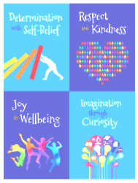

- Ensure careful and considerate parking at the school entrances, respecting safety regulations and our neighbouring community;
- Read the information from school regularly, so that I am up to date with important details.

`As a pupil, I will:
- Be kind, honest, respectful and helpful to other children and adults;
- Try my best, listen carefully to instructions and be independent in all aspects of school life;
- Be responsible for my learning (at home and at school);
- Let an adult know about anything that I feel may affect my learning or behaviour or that I am worried about;
- Behave safely at all times, including online;
- Bring all the equipment that I need every day;
- Take care of my belongings, the school environment and living things.
- Reflect and accept responsibility for my actions if I have made a mistake in my behaviours.
Signed (school): 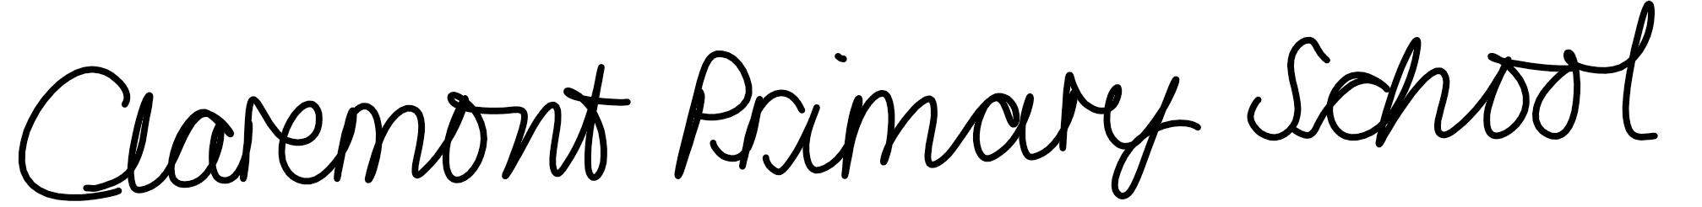

Signed (parent/carer): ……………………………..……………….
Date: ………………………………………………

Signed (parent/carer): ……………………………..……………….
Date: ………………………………………………

Signed (child): ……………………………..……………….
Date: ………………………………………………

